Interior

Forecabin

Beds
To reduce the condensation that you can get under the mattresses, I have insulated under the fibreglass bed bases with PUR/PIR foam, stuck on with something like “Sticks like sh1”t, having pulled off the aluminium on one side of the sheet.
http://www.jewson.co.uk/building-materials/thermal-insulation/purpir-insulation/products/IRESR025/recticel-eurothane-gp-insulation-2400-x-1200-x-25mm/
In this cabin, I have done it under the fore-section of the bed, the hatch cover and over the water tank. The photo shows the foam on one of the smaller hatch covers.
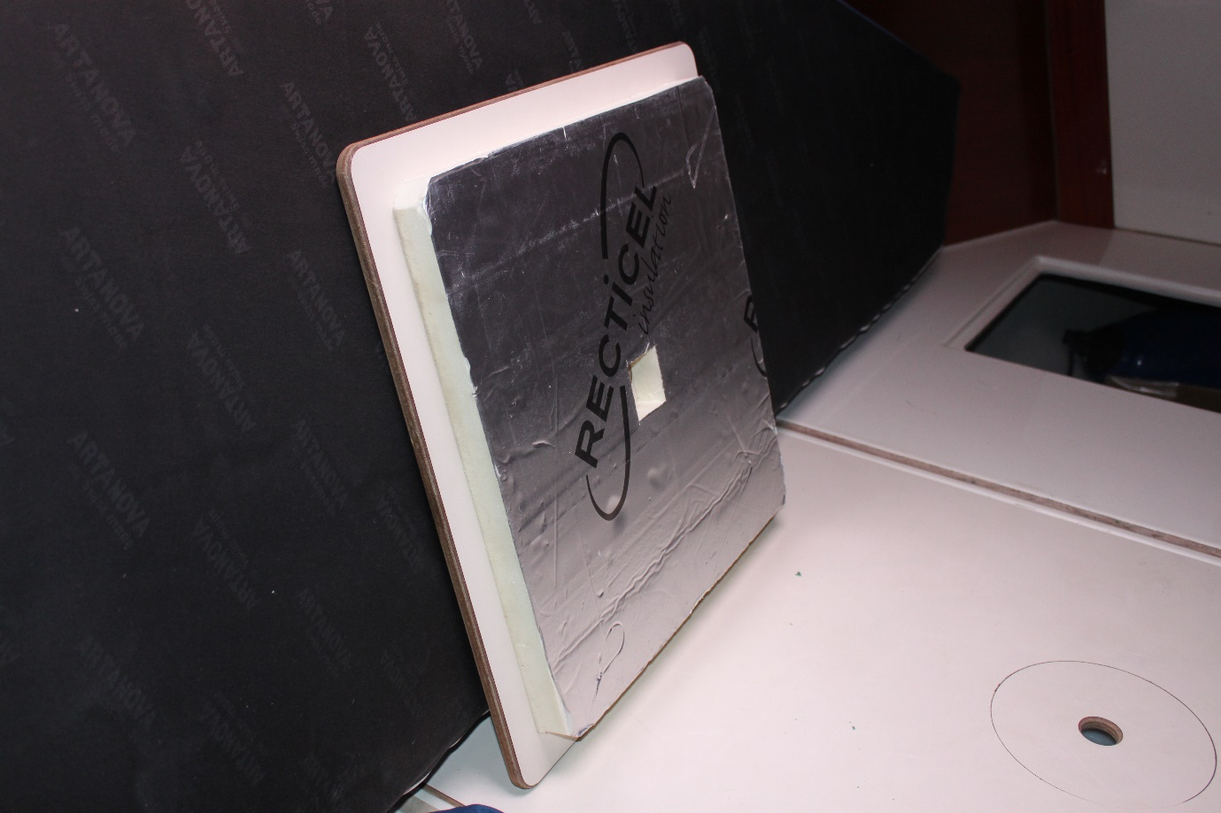

Lighting
The cabin is not well lit, so I have fitted 2 lights, the same as the bulkhead lights in the saloon, directly thorough the bulkhead from those in the saloon, so it is just a short wiring job.
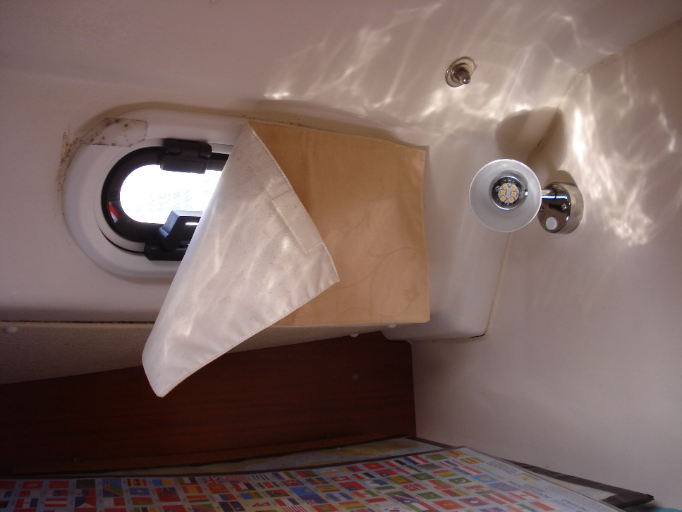

Saloon

Hatch by Mast
I store tools in here and so I did not want to damage the sensors, I glassed in 3 wood blocks onto the hull and use a couple of plastic clips to secure one of the kitchen cereal containers over the sensors.

Large Floor hatch behind table.
On my yacht, you cannot see the shower pump filter, so I have to take the whole floorboard up to clean it. I have fitted a non-return valve in the outlet pipe from the shower pump, as this stops water running back onto the shower floor, after you switch the pump off.

Rear Starboard Under Seat Locker

Water Filter
Rene did not like the taste of the water from the tank, so I have fitted a water filter (Jabsco Aqua Filta) on the bulkhead, between this locker and the back of the cupboard. It feeds just the kitchen sink tap and the existing hose from this tap is connected to the filter and a new piece of hose connects it to the main cold-water supply pipe. Because of the pressure in the system, the joints need 2 clips.

Coolant Piping
Condensation forms on the fridge coolant piping, so I have insulated it with small diameter pipe insulation from the compressor to as far down the fridge as you can get.

Insulation on Heating Pipe
Having the hot-air ducting next to the compressor is not good, so I have insulated the ducting with sleeves from Eberspacher. I have insulated as far as I can back under the cooker

Extra Fan on Compressor
In a hot summer, many moons ago, it became clear that the locker became warm. I have therefore fitted an extra fan into a piece of plastic piping in parallel with the existing fan to pull cool air from the bilge over the cooling coils and into the cabin. See photo.
http://www.myhanse.com/fridge-comprressor-cooling_topic7850_post61462.html?KW=fridge#61462
The fan was an 80mm Acousti Fan from www.quietpc.com. It is now set to pull the air from the bilges and blow it into the saloon
I do not know what it did to the acoustics, but we reckon there is now less noise in the saloon from the fridge.

Heads

Shower Head
We fitted an adjustable shower head with valve from Penguin Engineering, so that you can reduce the flow whilst showering without altering the tap and heat settings.
I think it is something like
http://www.penguineng.com/TapsShowers/Showers-ElbowShowerHeads/D91PenguinTap.php

Towel Hooks
I just fitted towel hook rack from B&Q on the top of the wall opposite the loo.

Kitchen

Fridge Insulation
On the Myhanse website, Skipper did a marvellous description of putting expanding insulation foam around the fridge.
https://www.myhanse.com/reduce-compressor-running-time-with-up-to-50_topic5008.html
I did not have the nerve to do that, so I have used the same insulating foam that I described earlier. With difficulty, you can slide in sections in forward and astern of the cool box, underneath the cool box base and on the inner side of the cool box. If I was to do it again, I would glue the forward pieces to the back of the seat, as I did start to get some condensation, as I had created a cool spot behind the cushions.

Extra shelf
I have used L brackets to secure a small shelf about 60mm down from the top of the cupboard behind the cooker, on which we store the rolls of cooking foil and cling film. Keep the shelf short, so you can still store bottles in front of it.

Cooker
On the gas check, as the pipes were so old, the gas engineer replaced the rubber tubing with reinforced hose.
When sailing, we always close the starboard cabin door, as if the cooker is swinging then it will mark the door.

Sink Drains
There was long discussion on the MyHanse site on the basis that the sink s drain slowly. The solution of moving the point where they meet to be above the waterline, did actually increase the drainage rate

Rear Cabins

Under Bed Insulation
In both cabins, I have insulated as much as possible under the bed bases, the same as under the front bed, apart from on the battery box lid. I have also put insulation on the ducting underneath the starboard bed.

Alternator Regulator
In a hot summer, we were short of power on a long trip, so as well as insulating the fridge and replacing the domestic batteries, I installed a Sterling Alternator to Battery regulator in the port cabin. It is probably slightly overkill, as we are often in a marina. The hard part was the fact that the wiring diagrams I found in the Yanmar handbook and for the Hitachi alternator were misleading or in fact inaccurate. If necessary, I can help you out on this one.
See
https://www.myhanse.com/adding-a-sterling-alternator-to-battery-regulator_topic8790_post70867.html?KW=sterling#70867

Rear Lazarettes

Port Side

Calorifier
It is a common occurrence to have the safety/drain valve on the calorifier leak as the pressure builds when the water is heated. You may be able to adjust the water pump pressure setting on the pump in the saloon port locker, to as low as is acceptable by a knob on the top of the pump. I also fitted a piece of rubber tubing over the calorifier safety valve and run this up to the stern shower outlet fitting, where it goes through a small hole, so any leakage goes overboard.
On my yacht, one of the hose elbow fittings leaked, as you could not tighten it up and fit the rubber hose over it. I ended up using Loctite on the elbow to set it in the right orientation and then refitting the hose.
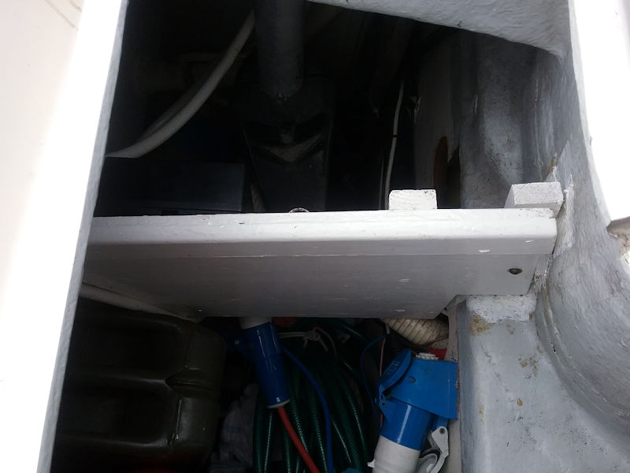

Bulkhead
Given the problems with the hoses, I glassed in a few pieces of wood around the locker so that I could put in a plywood bulkhead about 50cm high to protect the calorifier. It is just fastened in with a couple of screws so I can take it out when I want to finally drain the calorifier.
As an aside, I do the first draining of the calorifier, by putting the shower head on the shower floor with its hot tap open and a cold tap in the kitchen open when the water pump has almost drained the tank and you can get a syphon effect to empty most of the water out of the calorifier. Then I just drain the last portion of water through the valve.

Starboard Locker

Heater
The heating ducting does a 180deg turn on my boat from the Webasto heater and the hose failed last year. As I replaced it, I put on insulation on the ducting in the locker.

Stern Shower Head
We had the widespread problem in that the Plastimo shower head froze and when it thawed out, it started pouring water into the bilge. The chandlers ran out of shower heads that day. I have glassed in a piece of wood inside the transom and fastened a ball valve onto this just before the flexible pipe starts.

Bulkhead.
I have also fitted a small bulkhead into this locker to ensure that nothing can fall over and jam the steering yoke.

Seacocks
During this winter, I have had an engineer replace all the through-hulls and seacocks, as they are now 16 years old, though my yacht is out of the water around 5 months each year. Based on many comments, they are worth checking.

On Deck Changes, have mainly all been covered on the forum

3rd reefing system
https://www.myhanse.com/single-line-3rd-reefing-setup_topic10548_post96364.html?KW=reefing#96364

Controlling the Jib downwind
https://www.myhanse.com/controlling-the-jib-downwind_topic10476_post88083.html?KW=barber#88083

Tack line for cruising chute
https://www.myhanse.com/bullseye-for-tackline&KW=chute_topic10634_post89225.html#89225

Using a snuffer on a cruising chute, towards the end of this thread
http://www.myhanse.com/snuffers_topic10698_post89894.html?KW=chute#89894

Size of dinghy
https://www.myhanse.com/size-of-inflatable-dinghy_topic6485_post49518.html?KW=#49518

Anchor Windlass
https://www.myhanse.com/retrofitting-a-windlass_topic11393_post94665.html?KW=windlass#94665

